Revision Units 1 - 10

We have successfully covered all the 10 units in the book. Before we continue with learning new things, it’s important to make sure you know and understand everything we’ve dealt with so far. This and next week, your task will be to refresh your memory and polish up your knowledge of the basics of English as well as the more advanced grammar and vocabulary.

Everyday, go through one Unit online, using the Oxford University Press resources on this website:
https://elt.oup.com/student/solutions/preint/?cc=sk&selLanguage=sk
Click on Grammar, Vocabulary, Everyday English (and games if you like) and do all exercises in each category.
Thursday – Unit 1, Friday – Unit 2, Saturday – Unit 3, Sunday – Day off, Monday – Unit 4, etc. until you have done Unit 10.
Remembering things you already know or are supposed to know is very important.
Here’s an example of Everyday English exercise in unit 1. Your task is to click on the word that is incorrect and write the correct one below.

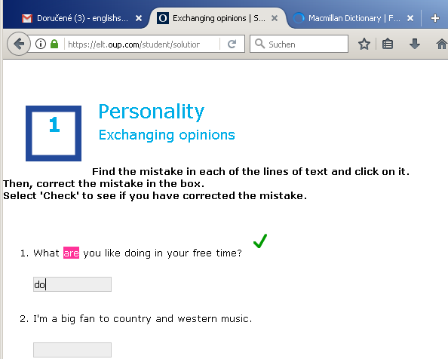

Important: Send me a screenshot (or a photo) of an exercise you’ve done from each unit. Send it in an email (englishsosban@gmail.com) with 10 attachments (or two emails 5+5) – one screenshot of a completed exercise (Vocabulary or grammar or everyday English) from each Unit 1, 2, 3, ...10 by June, 8th midnight.

Pre istotu pár inštrukcií po slovensky: Čaká nás opakovanie všetkého, čo ste sa z červenej Solutions knihy doteraz naučili. Posielam link s online opakovacími cvičeniami z každej lekcie. Vašou úlohou je každý deň si zopakovať jednu lekciu (Unit). Mali by ste všade dosiahnuť aspoň 70 % (je to opakovanie), ak nedosiahnete, zopakujte si to učivo/slovnú zásobu. Do 8. júna mi treba poslať 10 skrínšotov :) z každej lekcie ľubovoľné vypracované cvičenie (cvičenia máte urobiť všetky, fotka stačí z jedného) odfoťte a uložte fotku. Do mailu, englishsosban@gmail.com priložte tých 10 fotiek (z každej lekcie jednu) a odošlite (najneskôr pondelok 8. 6. o polnoci), prípadne pošlite na messenger, ale aby to bolo čitateľné.

