ÚLOHY AKTUÁLNE POČAS CELÉHO OBDOBIA TRVANIA MIMORIADNEJ SITUÁCIE – 1.A POD
Zopakovať všetky doposiaľ prebrané lekcie z učebnice Solutions Pre-Intermediate , t. j. od 1 – All about you až po 3 – House and home vrátane, čo sa týka prebraných článkov, gramatiky, slovnej zásoby (Workbook) ako aj užitočných fráz. Zároveň je potrebné si urobiť všetky chýbajúce cvičenia z týchto lekcií v pracovnom zošite vrátane Self Check a Get ready for MATURITA.
ÚLOHA zo dňa 16.03.2020
V lekcii 3 je v časti 3G ponúknutý návod ako napísať dovolenkový/prázdninový blog, po preštudovaní tejto časti vrátane vzorových ukážok takýchto blogov je potrebné, aby sa každý študent zamyslel a samostatne napísal svoj vlastný dovolenkový/prázdninový blog, ktorý bude obsahovať informácie o tom, kde ste, s kým tam ste, ako ste tam cestovali, aké je tam počasie a či sa Vám tam páči, čo ste robili včera a aké sú vaše plány na zajtra a tiež kedy sa vraciate domov.
ÚLOHA (zo dňa 08.04.2020)
Spracovať tému č. 4 Lights, camera, action! Str. 34 až 43.
Gramatika (komparatív a superlatív + (not) as ... as, too, enough), slovná zásoba a frázy + pozrieť videá
https://www.youtube.com/watch?v=iykLae3KiXs
https://www.youtube.com/watch?v=q4xfTdojGEM
Cvičenia: 35/5 37/4 – kniha 31/1, 2, 3, 4 33/1,2,3, 4 - pracovný zošit
- v rámci Writing napísať krátku recenziu na film, ktorý ste nedávno videli
Úlohu zo 16.03, cvičenie 35/5 a 37/4 z knihy a recenziu na film (min. 10 viet), ktoré budú aj hodnotené mi posielajte na e-mail: petro.cibula@gmail.com
Termín: 21.04.2020
Príjemné prežitie Veľkonočných sviatkov vám želám

Keďže som pôvodne udal nesprávnu e-mailovú adresu (napriek tomu mi od väčšiny z vás odpovede prišli), predlžujem čas na zasielanie odpovedí do 30.04.2020 s tým, že namiesto cvičení 35/5 a 37/4 prosím zaslať cvičenia 35/4 a 37/6 .
Tým, ktorí mi odpovede zaslali ďakujem a prikladám správne vypracovanie cvičení:
35/5
- Who's the most talented actor in the world ?
- What's the most moving film that you've ever seen ?
- Who's the most beautiful actress in the world ?
- What's the dullest programme on TV?
- Who's the worst actor in the world?
- Who's the best-looking actor in the world?
- What is the scariest film that you've ever seen?
- What is the funniest comedy on TV?

37/4
- No. It wasn´t fast-moving enough.
- No, I don't. They are too predictable.
- Yes. It was too slow.
- No, she couldn't. She isn´t old enough.
- I can't, sorry. I'm too tired to stay awake.
- No, I haven't . It's too expensive.

35/4
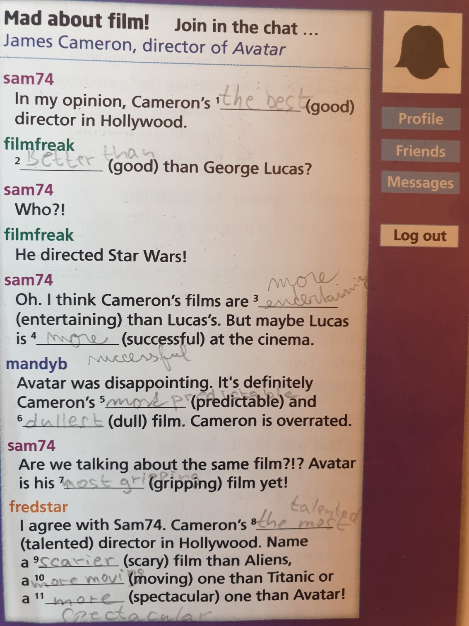

ÚLOHA (zo dňa 08.05.2020)
Spracovať tému č. 5 Shopping Str. 44 až 53.
Gramatika (present perfect simple and past simple), slovná zásoba (čo sa týka nakupovania a názvov obchodov) a frázy + pozrieť videá
https://www.youtube.com/watch?v=iVDomocdGak (rôzne druhy obchodov)
https://www.youtube.com/watch?v=vd0yESrQMs0
https://www.youtube.com/watch?v=UmdGwttUfKU (veľmi dobre vysvetlený rozdiel medzi použitím jednoduchého minulého času a jednoduchého predprítomného času)
Cvičenia: 45/6 47/5 – kniha 41/1, 3,5,7 43/1,2,3, 4 - pracovný zošit
Cvičenie CHECK IT OUT - skontrolujte uvedené vety a v prípade, že nie sú správne ich opravte.
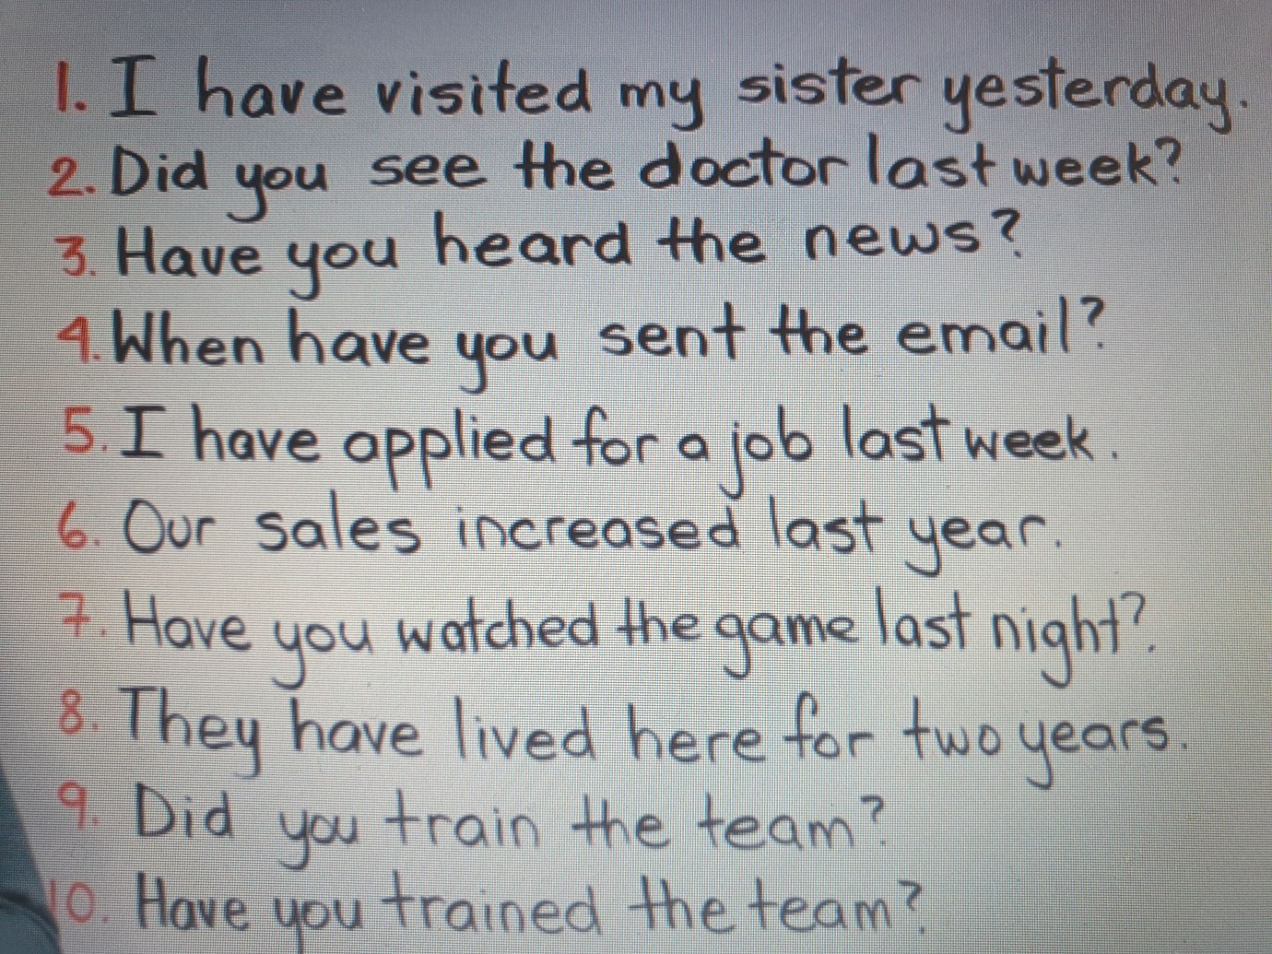
- v rámci Writing napísať sťažnosť/reklamáciu na chybný výrobok, ktorý ste zakúpili v obchode
Cvičenie 45/6 a 47/5 z knihy, cvičenie CHECK IT OUT uvedené vyššie a sťažnosť/reklamáciu na výrobok (min. 5 viet), ktoré budú aj hodnotené mi posielajte na e-mail: petro.cibula@gmail.com.
V prípade otázok, nejasností či pripomienok ma neváhajte kontaktovať.

Termín: 18.05.2020
Správne vypracovanie cvičení:
45/6
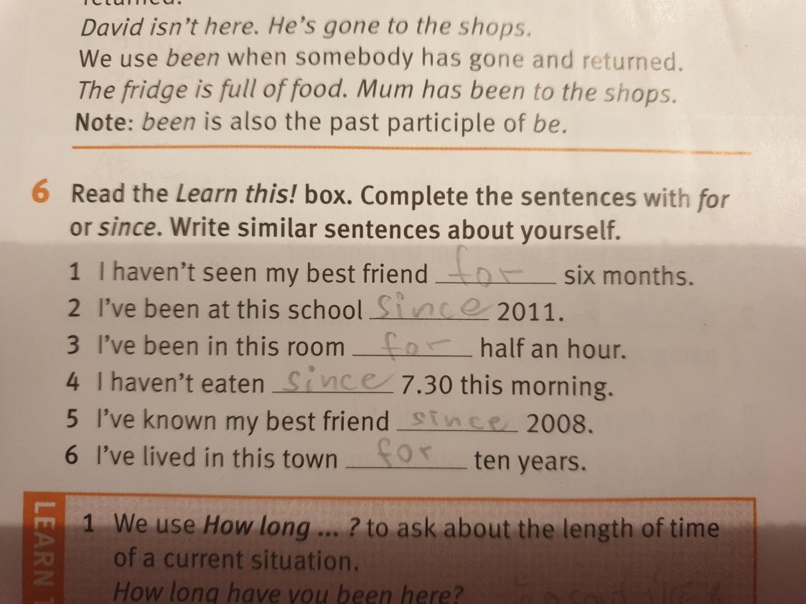

47/5
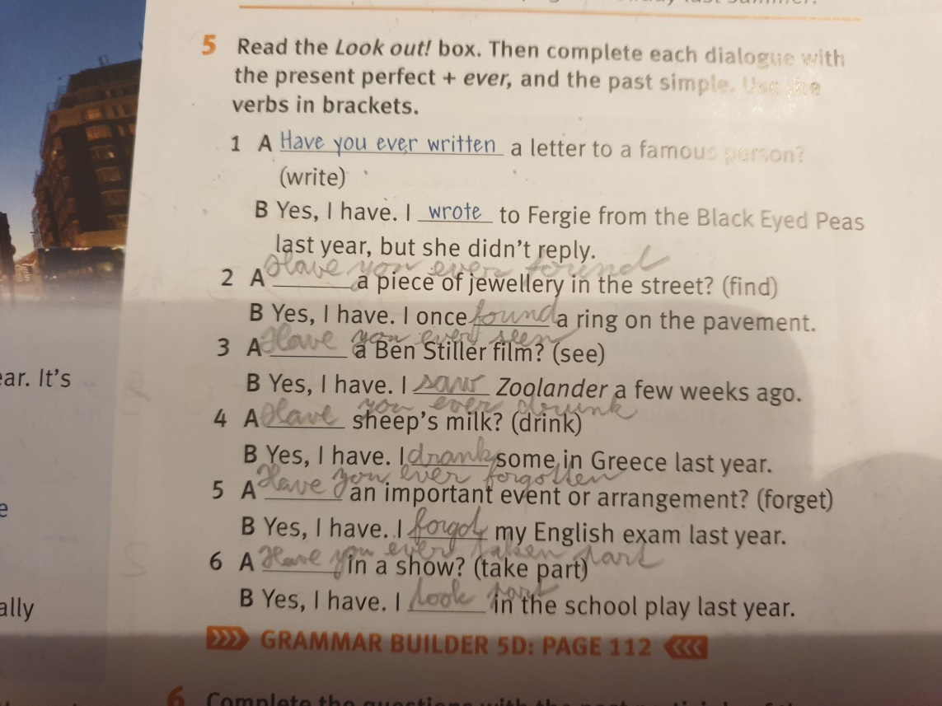
CHECK IT OUT
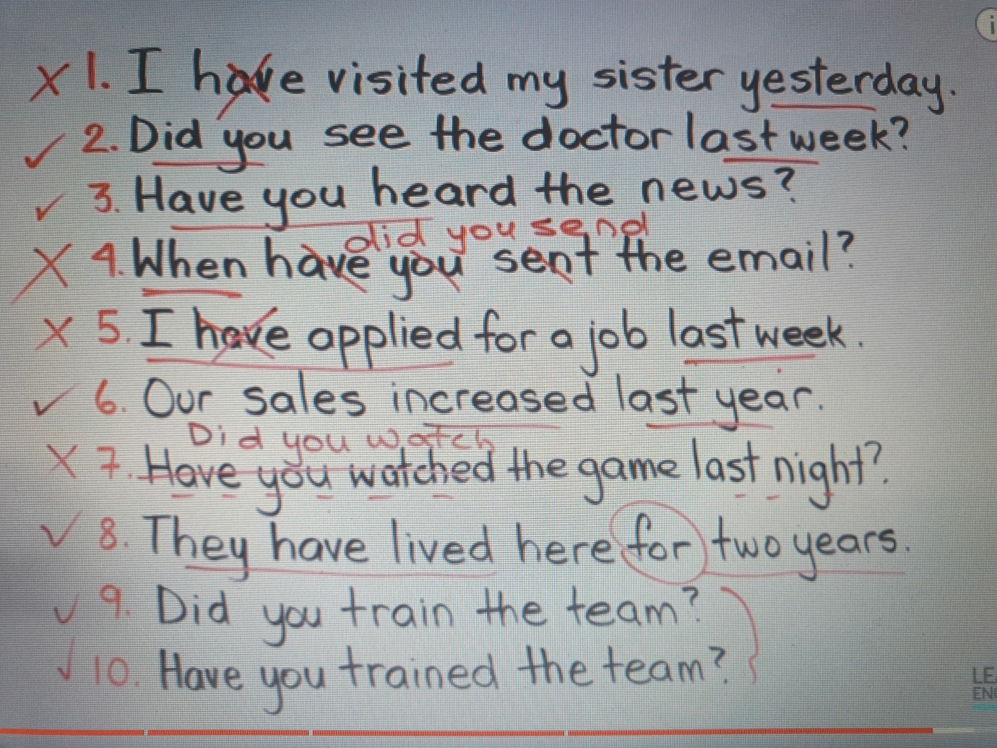

Writing:
Medená 119
974 05 B. Bystrica
3rd February 2020
Customer Services Center
Dragovského 25
735 04 Podrečany

Dear Sir or Madam,
I am writing to complain about …….. that I bought from your shop in ……….. on ……. . (A)
It works fine when I ….., but when I try to ….., it doesn´t work. (B)
I am returning …… to you with this letter. I would be grateful if you could repair the fault or
send me a new … . I would appreciate it if you could deal with this matter immediately. (C)

I look forward to hearing from you.
Yours faithfully
John Smith

AKTUÁLNA ÚLOHA (zo dňa 25.05.2020)
Zopakovať lekcie č. 1 až 5 (gramatika, slovná zásoba a frázy).
Nižšie vám prikladám kumulatívny test za uvedené lekcie, prosím skopírujte si ho do samostatného dokumentu a vyplnený mi pošlite na e-mail: petro.cibula@gmail.com.
V prípade otázok, nejasností či pripomienok ma neváhajte kontaktovať.
Termín: 05.06.2020

Name: ___________________________________________
Grammar
1 Complete the sentences. Use the correct form of the verbs in brackets.
1 Next weekend we _______________ (play) in a tournament against other schools.
2 _______________ (she / often / go) to fencing classes at the sports centre?
3 I hope _______________ (move) to the city next year. The countryside is boring.
4 Lisa! _______________ (you / listen) to me?
5 The department store _______________ (open) at eleven o’clock on a Sunday.
6 _______________ (you / fancy / see) that new Bond film with me on Friday?
Mark: ___ /6
2 Complete with the past simple, past continuous or present perfect form of the verbs in brackets.
Dave ¹_______________ (you / ever / try) snowboarding?
Alice Yes, we ²_______________ (go) to France last winter. My brother Harry ³_______________ (not enjoy) it very much, though.
Dave Oh, why not?
Alice He ⁴_______________ (fall) off the ski lift.
Dave Oh no!
Alice Yes, while he ⁵_______________ (go) up the mountain on the lift, another skier
⁶_______________ (crash) into him. Harry ⁷_______________ (break) a leg.
Dave Oh, bad luck!
Mark: ___ /7
3 Choose the correct answers.
1 There are only ______ students at school today.
a much b a little c a few d any
2 My cousins are vegetarians. They don’t eat ______ meat.
a – b the c a d an
3 I think chess is ______ game that I know.
a interesting b as interesting c more interesting d the most interesting
4 Are you ______ to run a marathon?
a as fit b too fit c enough fit d fit enough
5 Is there ______ orange juice in the fridge?
a many b any c some d a few
6 We went to Buckingham Palace, but we didn’t see ______ Royal Family.
a – b a c the d any
7 Vinnie is not as ________ Kyle.
a tall as b taller than c tall enough d taller as
Mark: ___ /7
Vocabulary
4 Read the text and complete the words.

Hi! I’m Dana. I’m sixteen, and I’m from California. I’m very ¹ t_ _ _ _ _ _ve. In fact, my sister says I’m never quiet! I don’t like waiting – I’m ² im_ _ _ _ _ _ _ – but I’m never rude or ³ na _ _y!
I’m quite sporty, and I enjoy playing ⁴ b_ _ _ _ _ll. I like doing ⁵ a_ _ _ _ _ _cs too. In fact, next week I’m ⁶ c_ _ _ _ _ing in a tournament.
I like music and I love films. I play the violin – I like ⁷ c_ _ _ _ _ _al music a lot. My favourite films are ⁸ r_ _ _ _ _ _c comedies. They can be predictable, but they’re so ⁹ e_ _ _ _t_ _ _ing. I don’t like ¹⁰ v_ _ _ _ _t films like war films or westerns.

Mark: ___ /10

5 Complete each sentence with one word from A and one word from B.

A DIY garden pedestrian rubbish street

B bin centre crossing lamps store

1 The traffic is dangerous here. You must use the ________________.
2 Dad bought some paint at the ________________. He promised to redecorate my bedroom.
3 The new ________________ has some lovely little trees – and they’re half price!
4 Don’t drop that paper in the street! Put it in the ________________. There’s one on the corner.
5 All the ________________ in our neighbourhood are broken. It’s scary at night now.
Mark: ___ /5

6 Complete the text with the words below. There are two words you do not need.

across audience ceremony hard-working respect through voluntary

My brother finished university today. It was his graduation. I went to the ¹____________ with my parents. They are so proud of him! He is incredibly ²____________ and clever. He looked nervous as he walked ³____________ the stage to get his degree, but then he saw us in the
⁴____________, and he smiled and relaxed. After university he’s going to go to India and do
⁵____________ work in a hospital there.

Mark: ___ /5

Use of English
7 Complete the text. Choose the correct options, A, B, C or D.

For some people Christmas is an ¹_______________ time of year, but for others it can be extremely stressful. Because of this, some people prefer to forget Christmas and go ²_______________, preferably to somewhere warm and sunny. But, judging ³_______________ the number of people out shopping, it's a time of year that most people want to celebrate in some way. The streets are usually ⁴_______________ on Christmas day though, as most shops don't open. People usually stay ⁵_______________, opening presents and having their Christmas dinner. However, others prefer to eat ⁶_______________ in restaurants or ⁷_______________ relatives. If the weather is nice, many people go ⁸_______________ for a walk, especially if there's snow. After dinner, they enjoy ⁹_______________ in front of the TV or playing board games ¹⁰_______________ the family.

1 A crowded B empty C enjoyable D scary
2 A away B home C out D shopping
3 A at B by C on D to
4 A crowded B empty C enjoyable D scary
5 A background B indoors C outdoors D underground
6 A about B around C into D out
7 A go B have C play D visit
8 A background B indoors C outdoors D underground
9 A relax B to relax C relaxed D relaxing
10 A at B by C to D with

Mark: ___ /10

Reading
9 Read the text. Are the sentences true or false?

Martin Blane is a farmer in Cornwall, in England. One summer, Martin noticed that something strange was happening on his land. He was standing on a bridge and looking at the wheat in his fields when he realised there was a strange picture in the wheat.
‘I looked and saw lots of circles in the wheat. The line of circles went across the field from the gate all the way to the end by the stream. They were very big. Other circles made a kind of picture in the wheat. I thought aliens had come from space.’
During that summer, and all through the 1970s, more strange pictures appeared in wheat fields on farms in the south of England. Nobody knew what these ‘crop circles’ were. Photographs of them appeared in all the newspapers and people thought the subject was gripping. Many thought that aliens had come to Earth and made the pictures.
But then in the 1990s two men admitted to making the crop circles. They made a plan for a picture and then they went out secretly in the night to make their picture in the fields. Some people think they were creative and the crop circles were entertaining, but their actions were illegal. The men were on land that didn’t belong to them. Farmers were angry because their crops were damaged. The two men promised to stop.
However, the crop circles are still appearing. On the Internet, you will find photographs of crop circles on farms in different countries around the world. Some people believe the two men were lying, and the crop circles are really made by aliens.

1 Martin Blane noticed that the animals in his fields were behaving strangely. _____
2 The big circles went from one end of the field to the other. _____
3 The media weren’t interested in the crop circles. _____
4 Everyone was angry because the men damaged farmers’ crops. _____
5 People disagree about who makes the crop circles. _____

Mark: ___ /5

Writing
10 You have bought a faulty item and you want to return it. Write a formal letter to the company.

- Tell them what the item is and when you bought it.
- Explain what the problem is.
- Tell them what you want them to do.
- Say that you hope the problem will be resolved quickly and thank them for their help.

Mark: ___ /10

Total: ___ /70

