Hello everyone ,
Topics for this week:
Subject: A life of crime – listening practice.
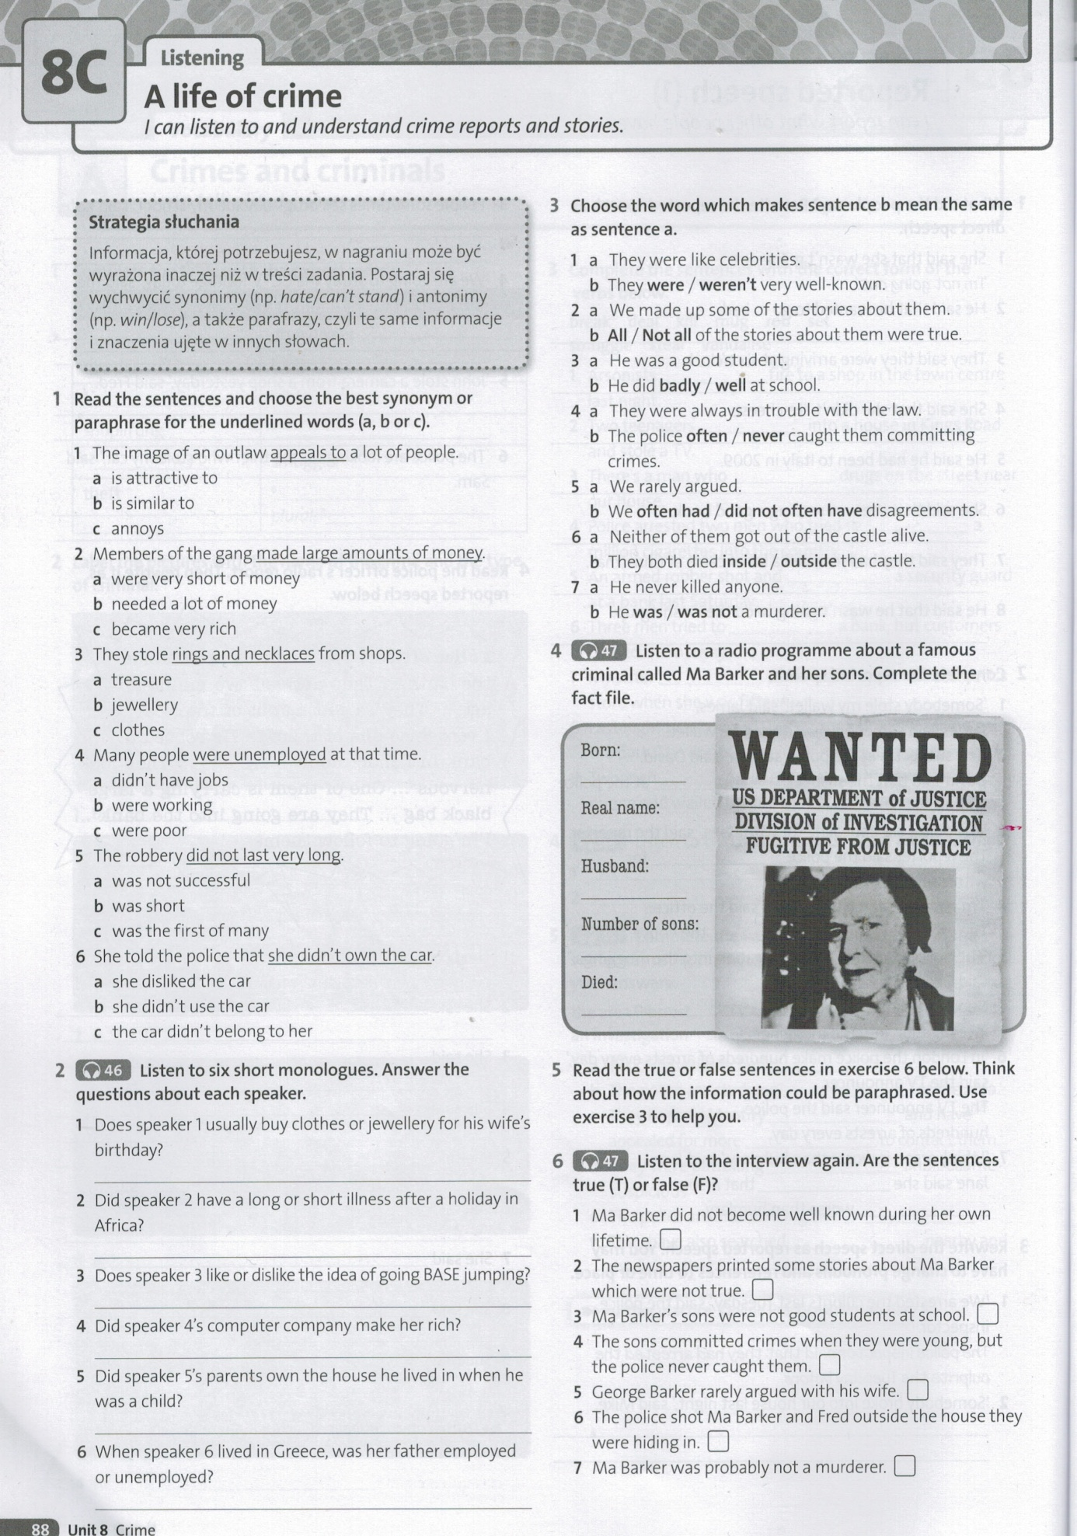
Subject: Photo description – practice.
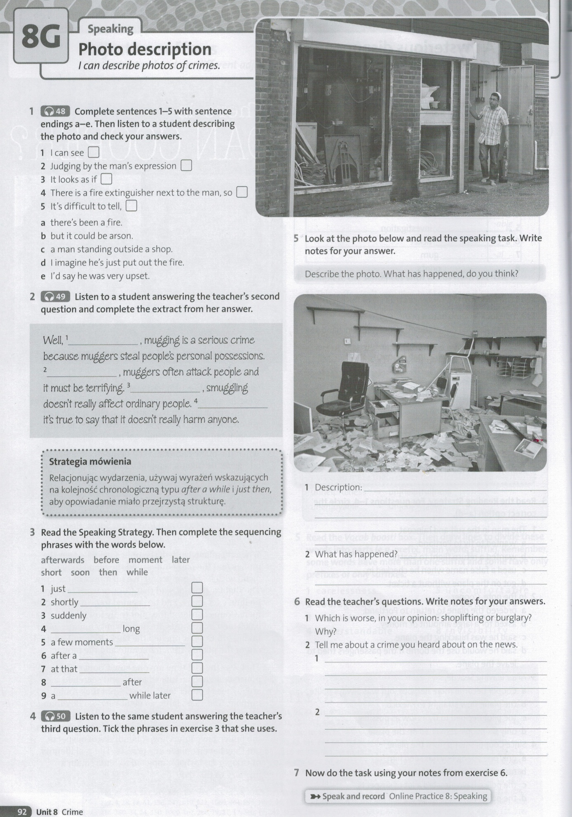
Subject: Writing an e-mail.
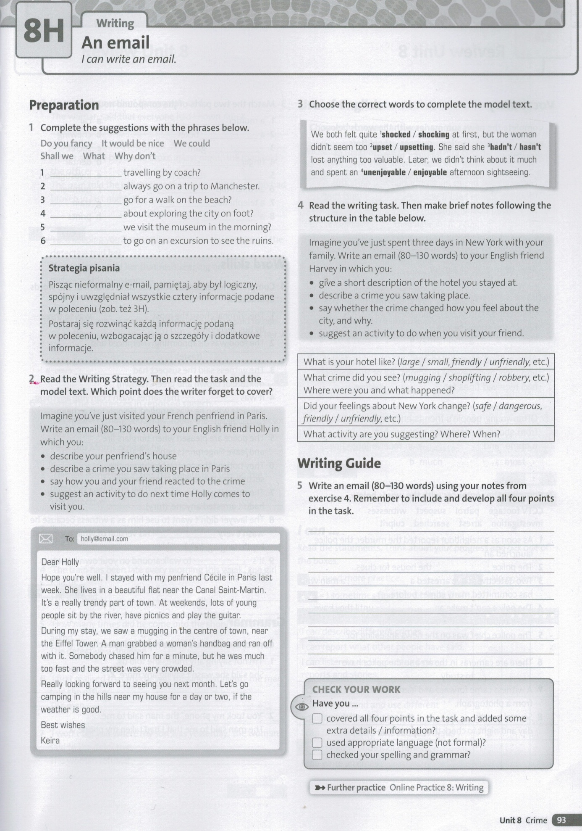
You can print the documents and send me the photos of your work till the end of this week.

